Hindi Vidya Prachar Samiti’s
RAMNIRANJAN JHUNJHUNWALA COLLEGE OF ARTS, SCIENCE AND COMMERCE
(EMPOWERED AUTONOMOUS)

Advanced Data Analytics


Name: Surajkumar Yadav
Roll no: 10404
Class: Msc. Data Science and Artificial Intelligence Part II


Ramniranjan Jhunjhunwala College
of Arts, Science and Commerce

Department of Data Science and Artificial Intelligence

CERTIFICATE

This is to certify that Surajkumar Yadav of Msc. Data Science and Artificial Intelligence Roll No-10404 has successfully completed the practical of Advanced Data Analytics during the Academic Year 2025-2026.

Date :

(Prof. Neha Ansari) External Examiner
Prof-In-Charge

INDEX
Sr. No | Practical | Date | Sign
1 | Learn all the basics of R-Programming (Data types, Variables Operators etc.)
2 | Implement R loops with different examples
3 | Learn the basic of functions in R and Implement them with examples
4 | Implement Data frames in R. write a program to join columns and rows in a data frame using c bind() and r bind() in R
5 | Implement different String Manipulation functions in R
6 | Implement different data structures in R (Vectors, Lists, Data Frames)
7 | Write a program to read a csv file and perform basic analysis in R
8 | Create pie charts and bar charts using R
9 | Create a data set and do statistical analysis on the data using R.
10 | Calculate Summary Statistics in Excel
11 | Generate Comparative Statistics in Excel
12 | Create Graphs in Excel
13 | Advanced Data Analysis using PivotTables and Pivot Charts
14 | Tabulation, bar diagram, Multiple Bar diagram, Pie diagram, Measure of central tendency: Mean, median, mode, Measure of dispersion: variance, standard deviation, Coefficient of variation. Correlation, regression lines.
15 | t-test, F-test, ANOVA one way classification, chi square test, independence of attributes.
16 | Time series: forecasting Method of least squares, moving average method. Inference and discussion of results.

Practical 1
Learn all the basics of R-Programming (Data types, Variables Operators etc.)
Sample data frame
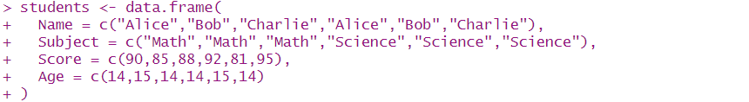
way 1
Mean Score by Name
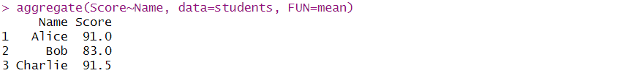
Mean score by Subject and Name
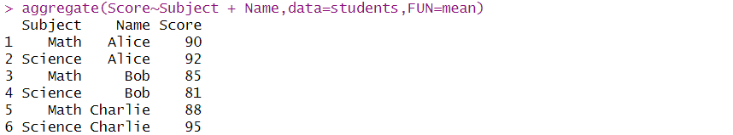
way 2
Average score per subject
Score by Subject and Name
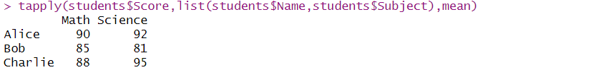
way 3
Group wise summary
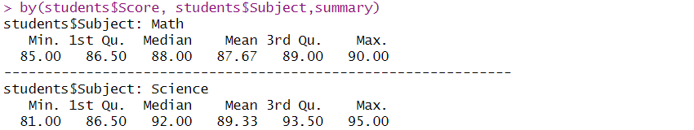

by subject and name
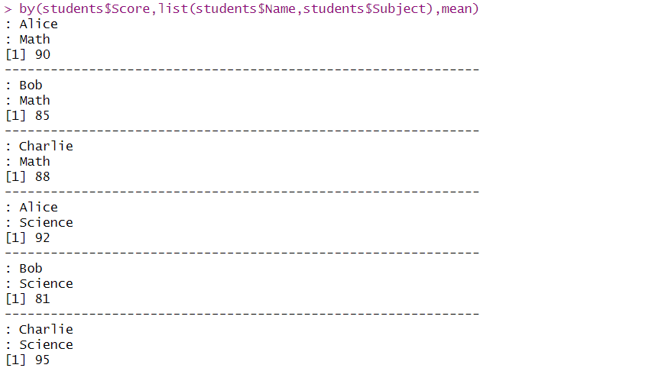
way 4
Average score by Name
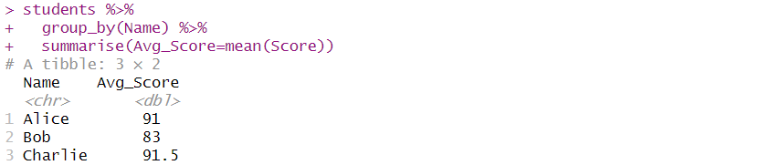
Multiple grouping
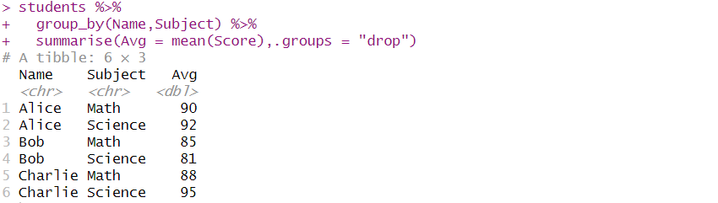
way 5
Mean score by name
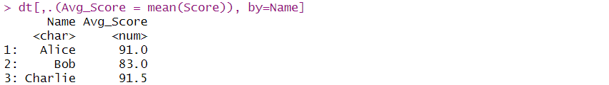
Mean and sum by subject
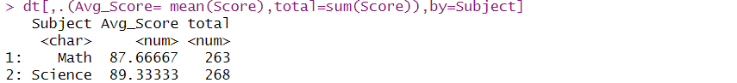
Group by two variables
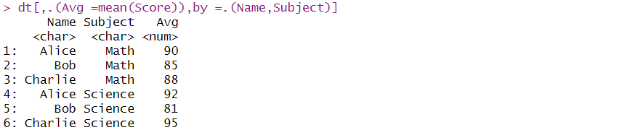
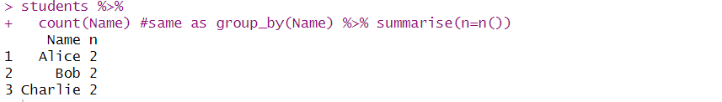
Create a sample data frame
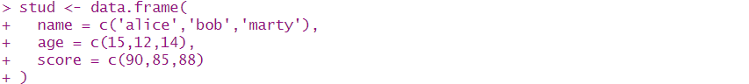
convert to json
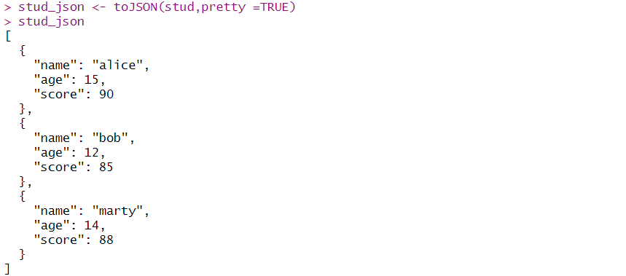
write json to file
Read JSON file
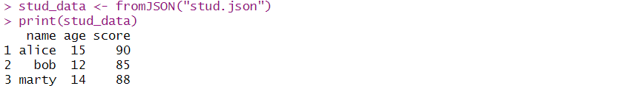
csv file
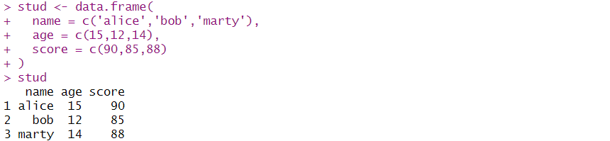
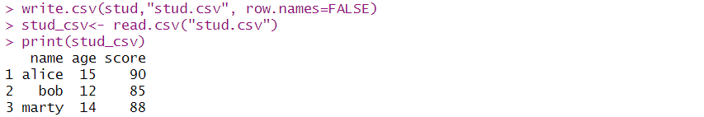
Read a tsv file using read.table()
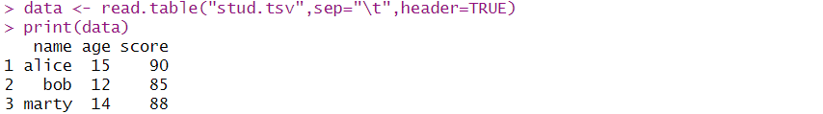
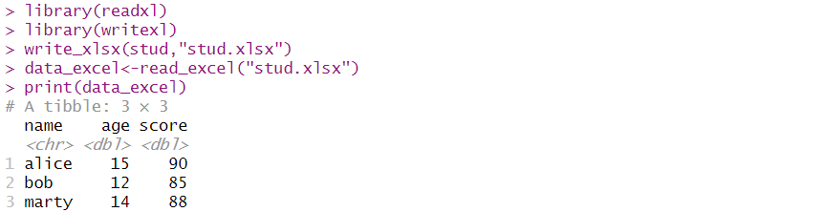
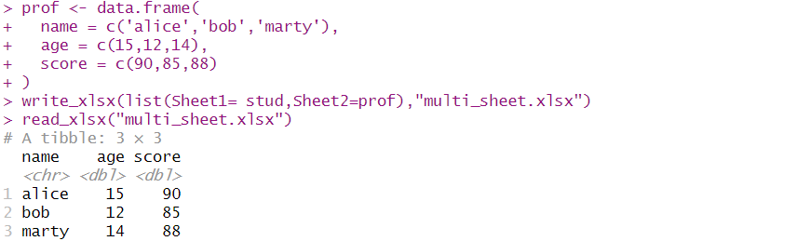

Practical 2
Implement R loops with different examples
Example 1: Using For loop:
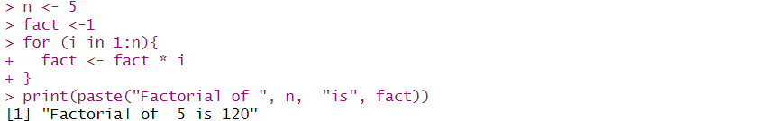
Example 2: Using While loop:
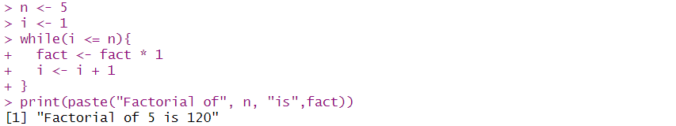
Example 3: Using repeat loop: [Ask for number > 10]
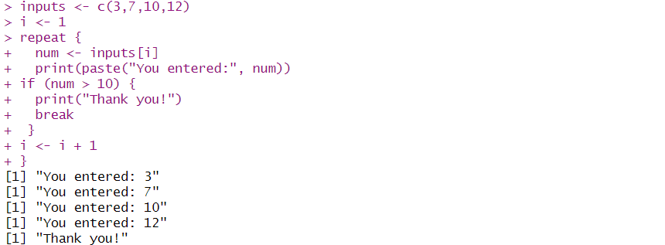
Example 4: Using While loop:
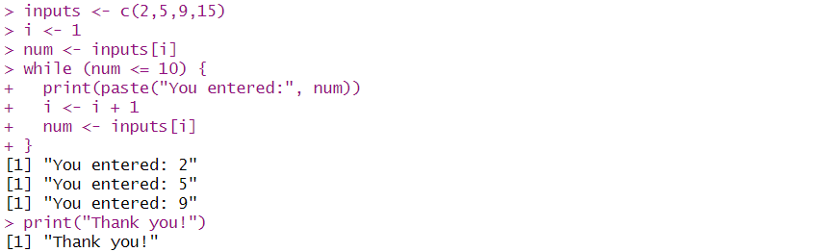

Example 5: Print triangle pattern
Using For loop:
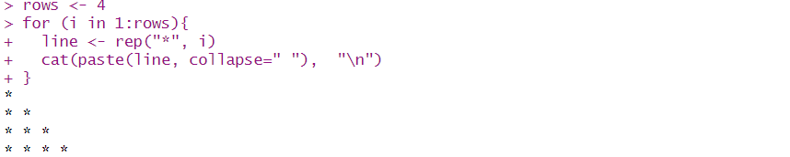
Using While loop:
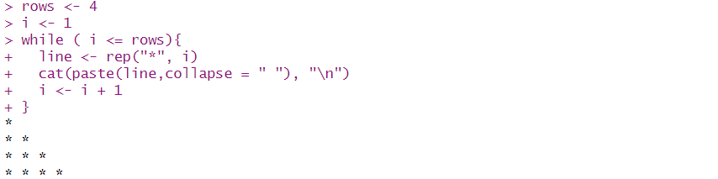
Example 6: Print student with score 80
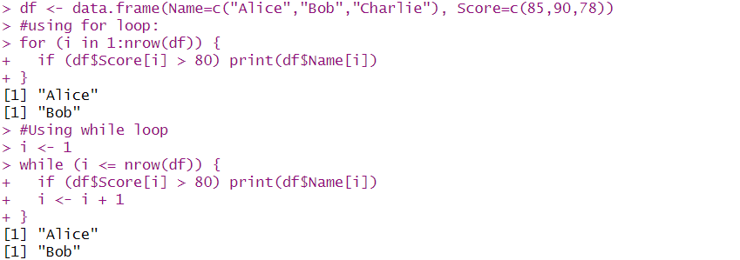
Example 7: Add 5 bonus marks
Using for loop:
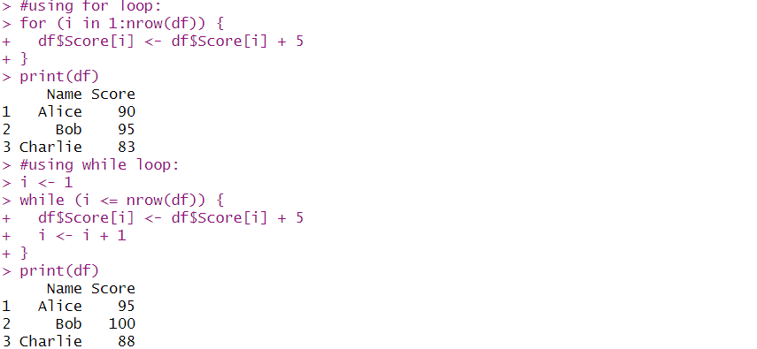

Using While loop:

Example 8: Add pass/fail result
Using for loop:
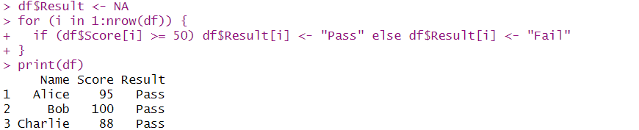
Using While loop:
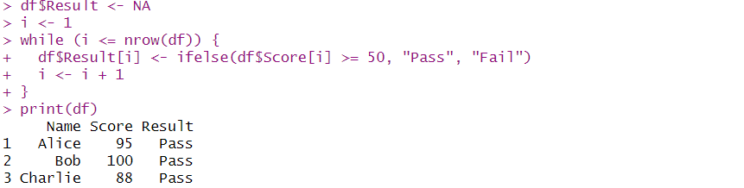
Example 9: sum list items using lapply
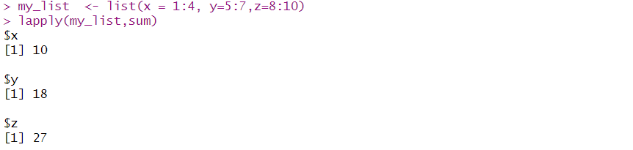
Example 10: max of each column using sapply

Example 11: Histogram using loop
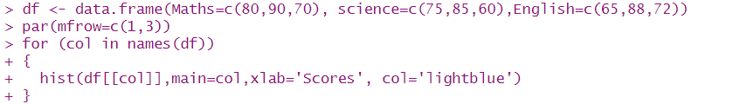
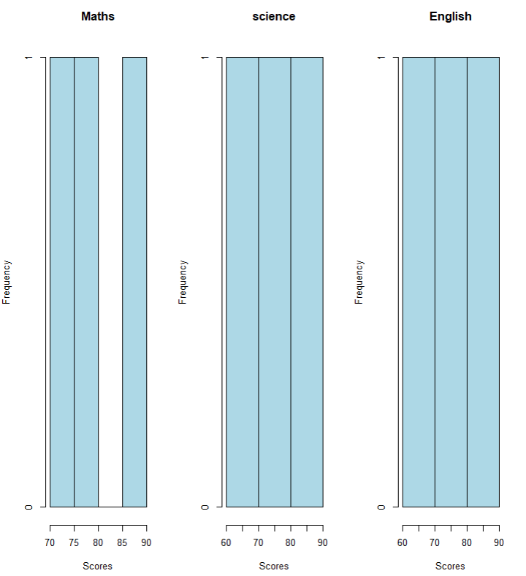
Example 12 : Applying Normalization using apply function
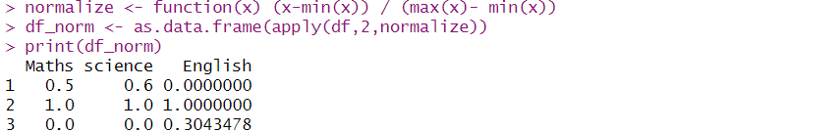
Example 13 : Add Grade column to the data frame and assign value to it
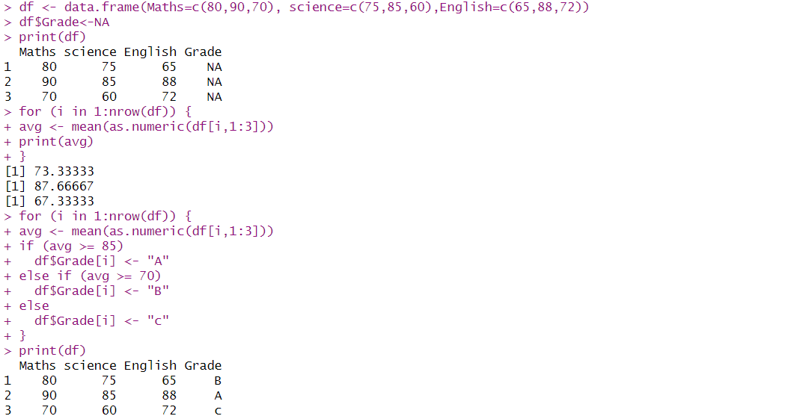
Practical 3
Learn the basic of functions in R and Implement them with examples
- Function without arguments
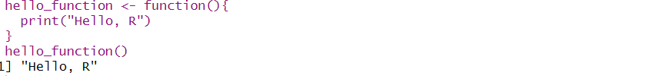
- Function with arguments
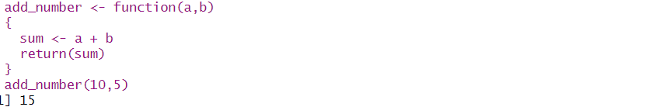
- Function with default arguments
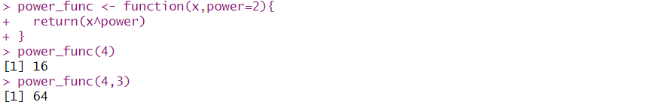
- Function returning multiple values
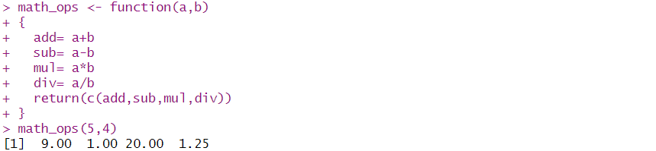
- Anonymous (inline) functions
- Functions with variable arguments
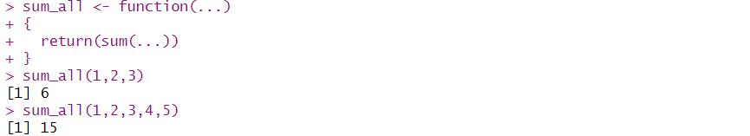

Practical 4
Implement Data frames in R. Write a program to join columns and rows in a data frame using c bind() and r bind() in R
Demonstration of c bind(), r bind() in data frame
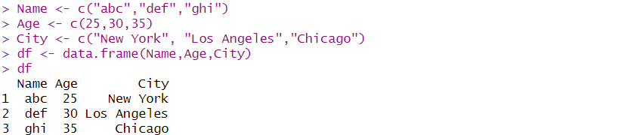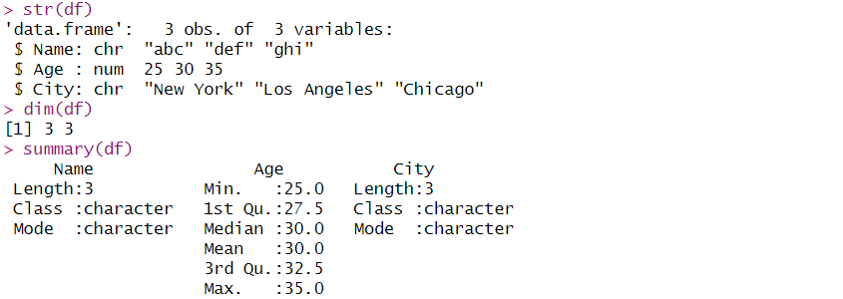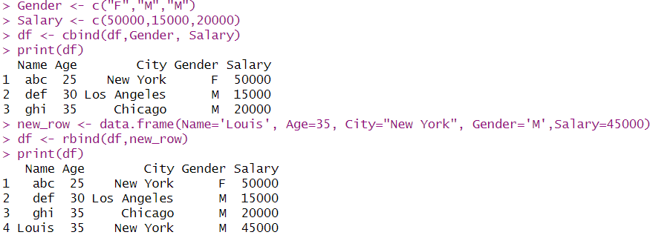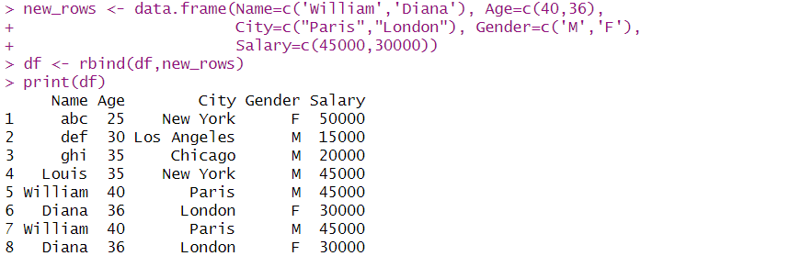

Practical 5
Implement different String Manipulation functions in R
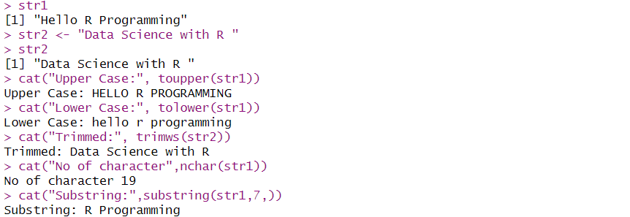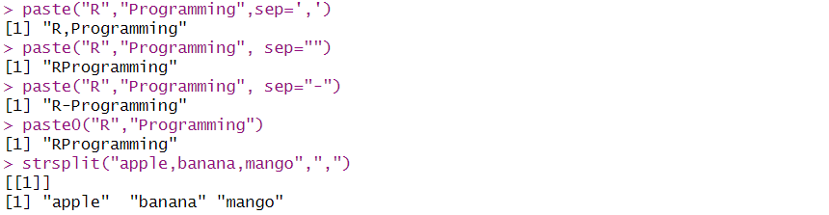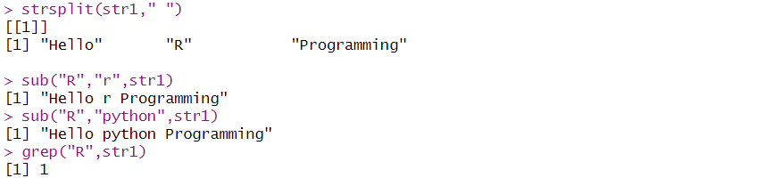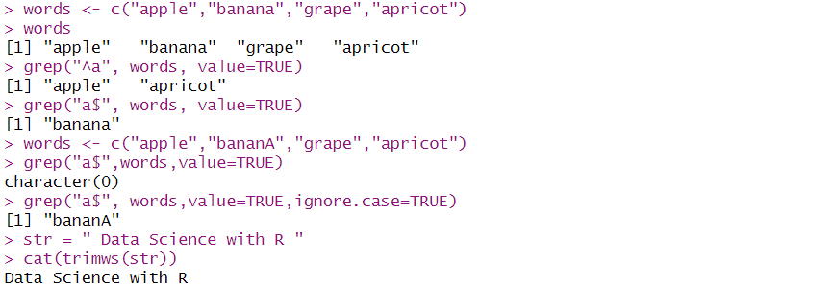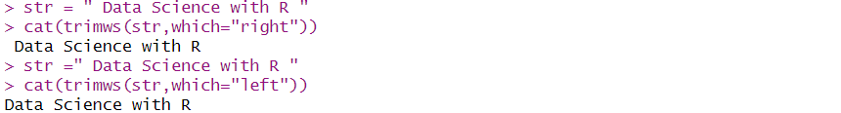
Practical 6
Implement different data structures in R (Vectors, Lists, Data Frames)
Factor and dataframe
install.packages('dplyr')
library(dplyr)
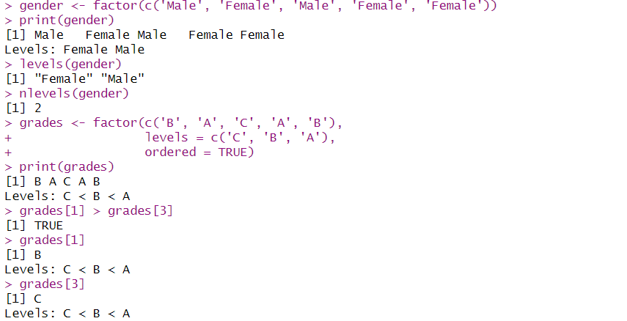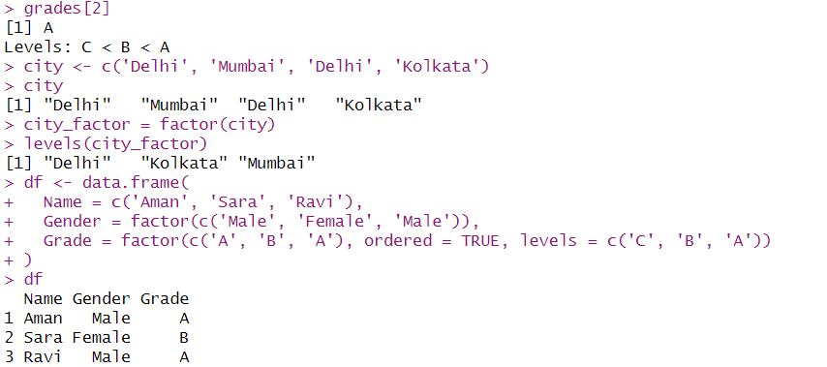
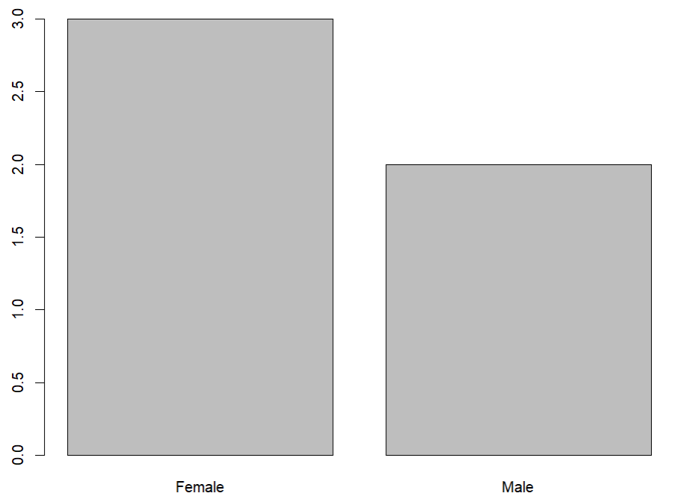
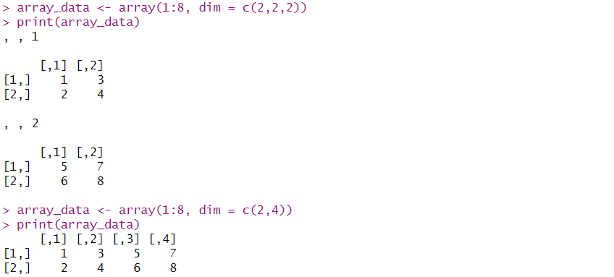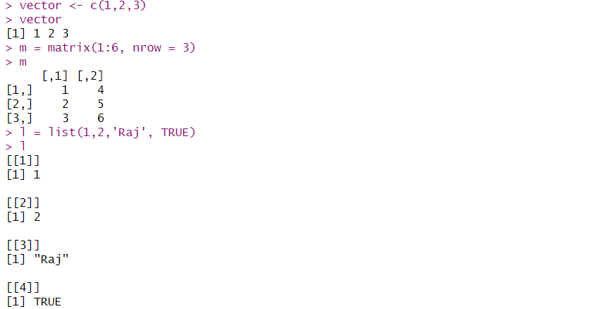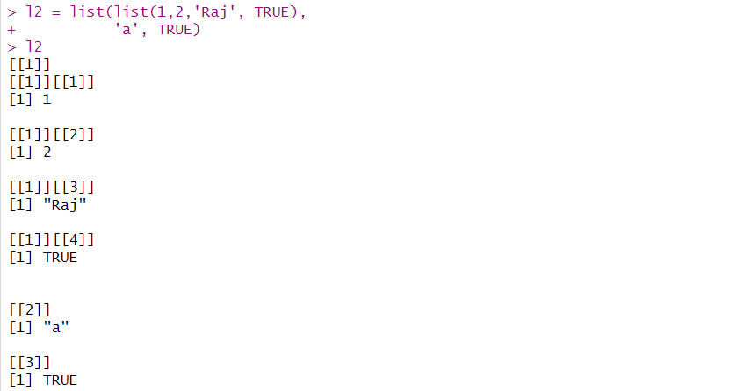
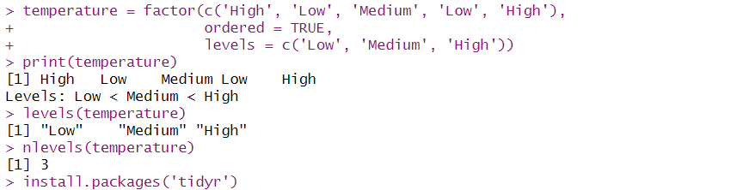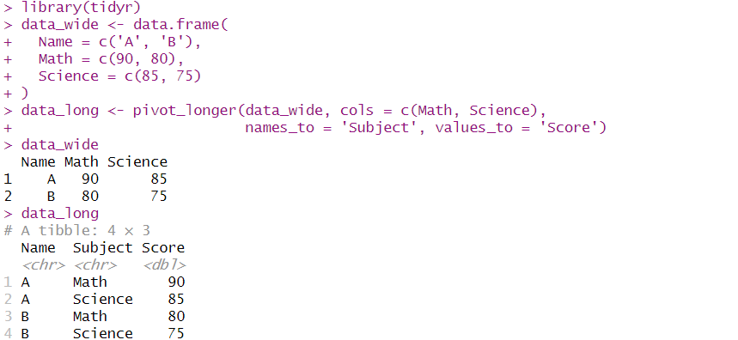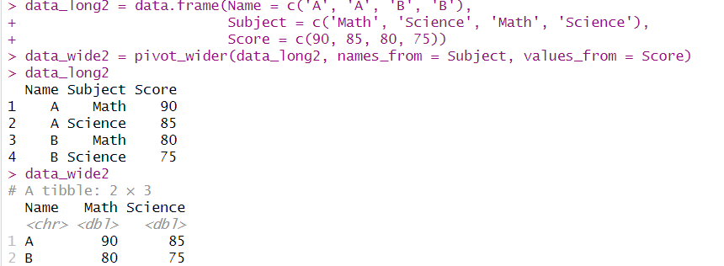

Date
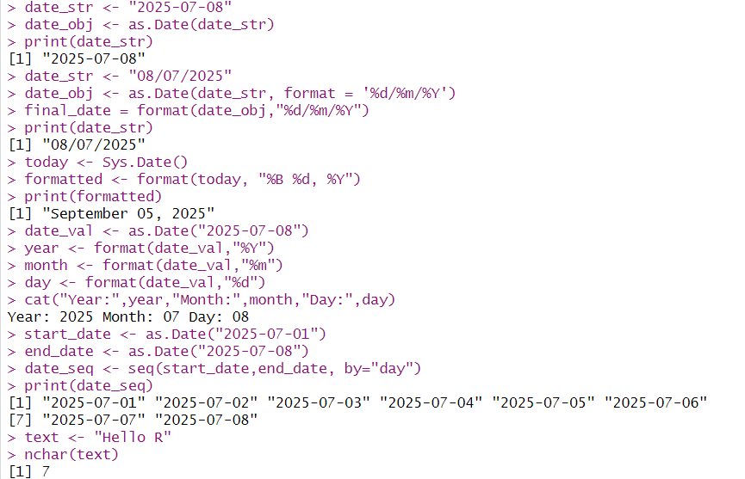
Character Manipulation in R
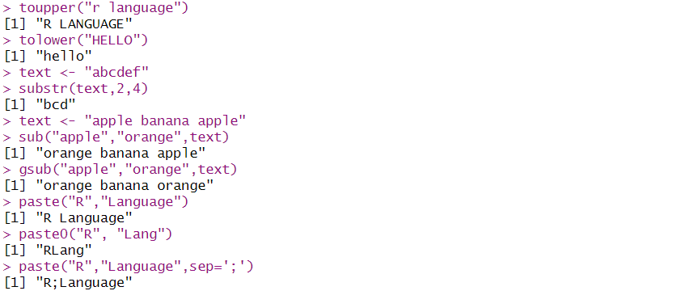

Practical 7
Write a program to read a csv file and perform basic analysis in R
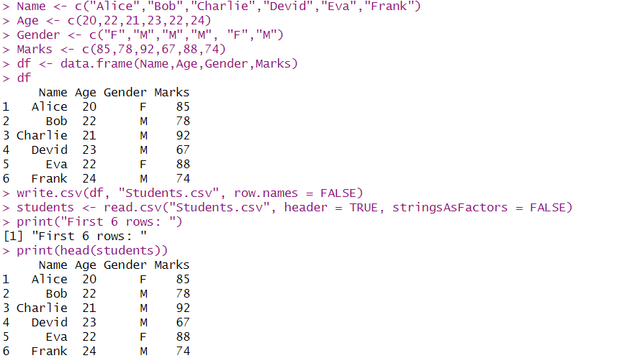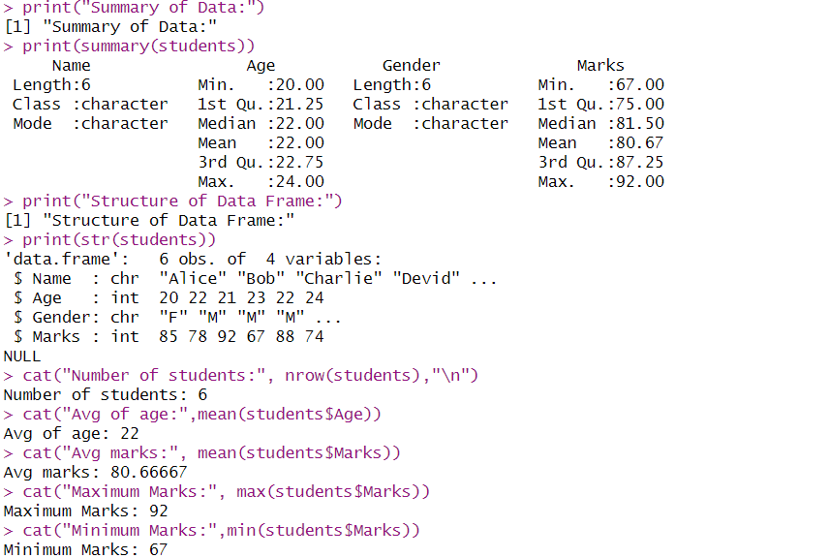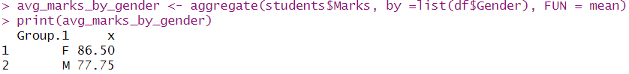
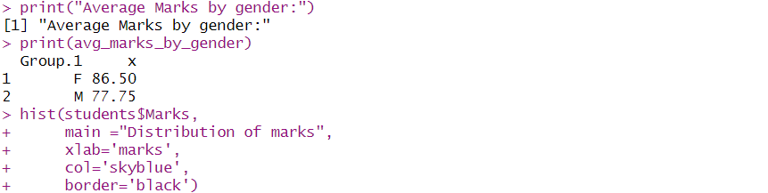
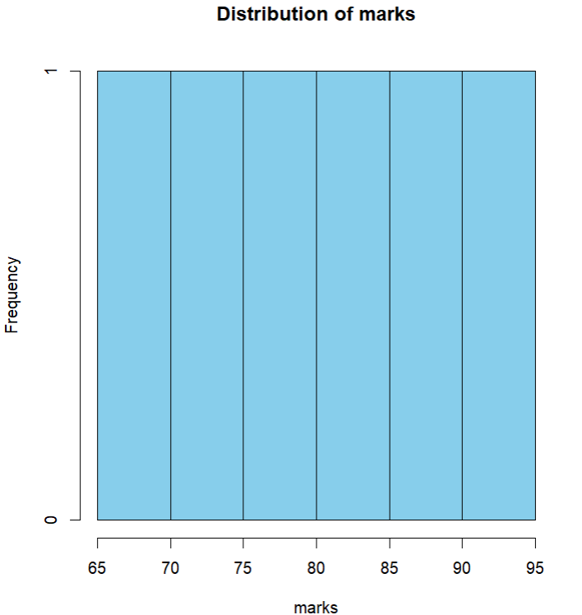
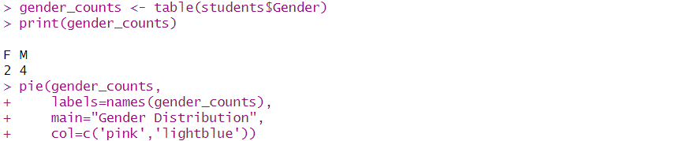
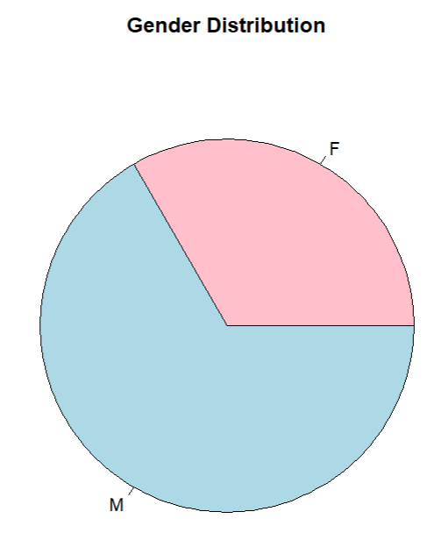

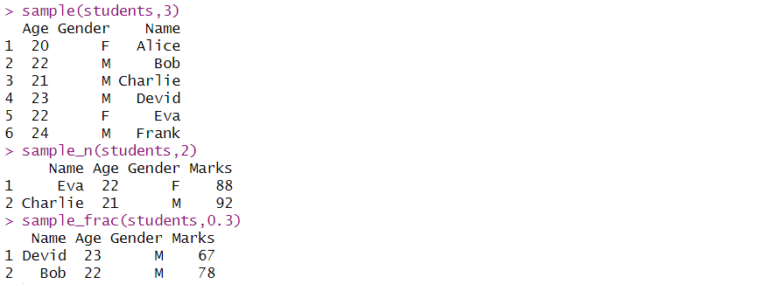

Practical 8
Create pie charts and bar charts using R
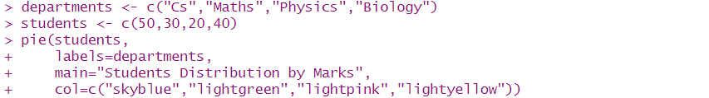
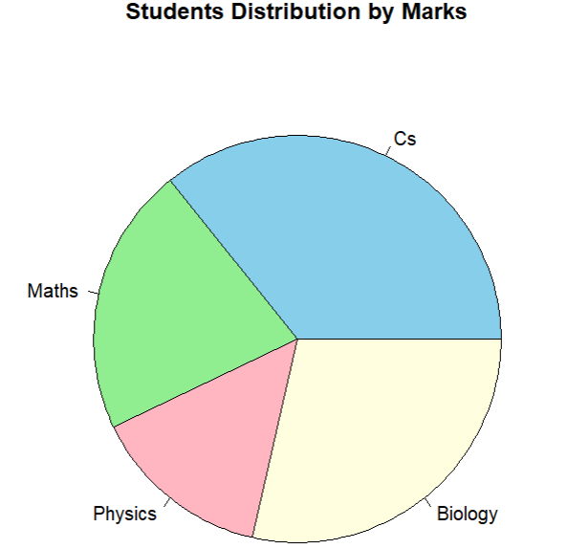
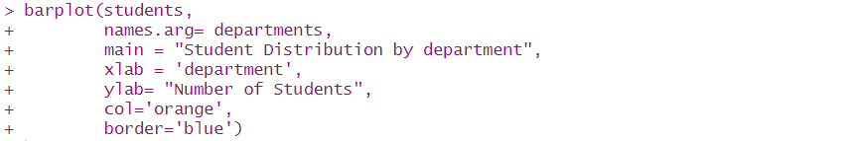
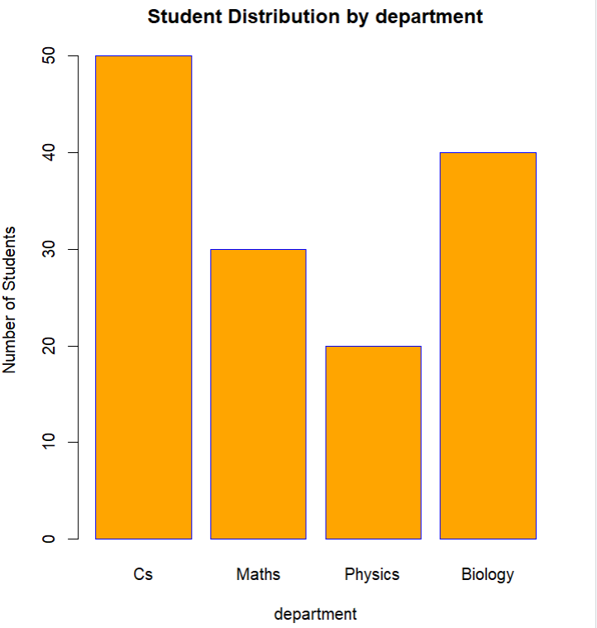
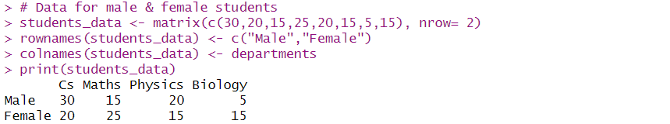
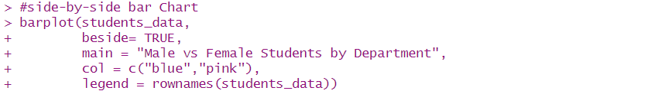
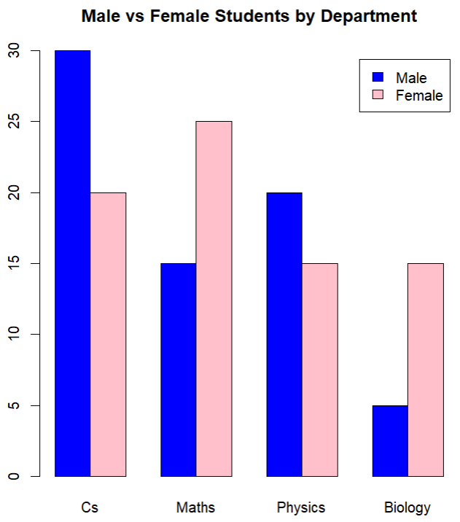

Practical 9
Create a dataset and do statistical analysis on the data
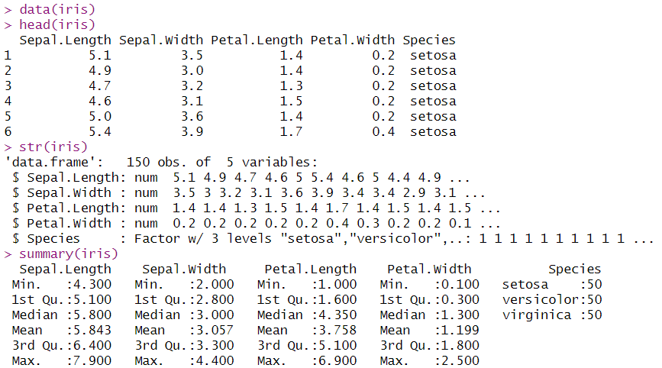
pie chat of species ditribution
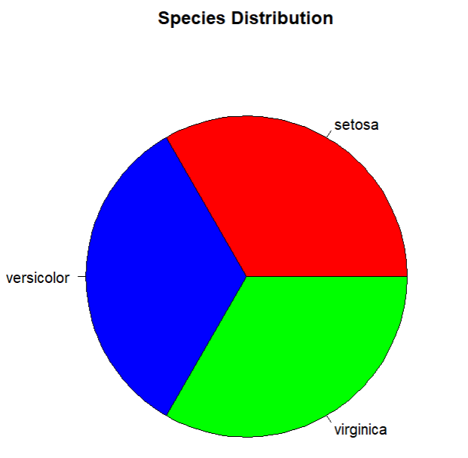
Histogram of sepal length
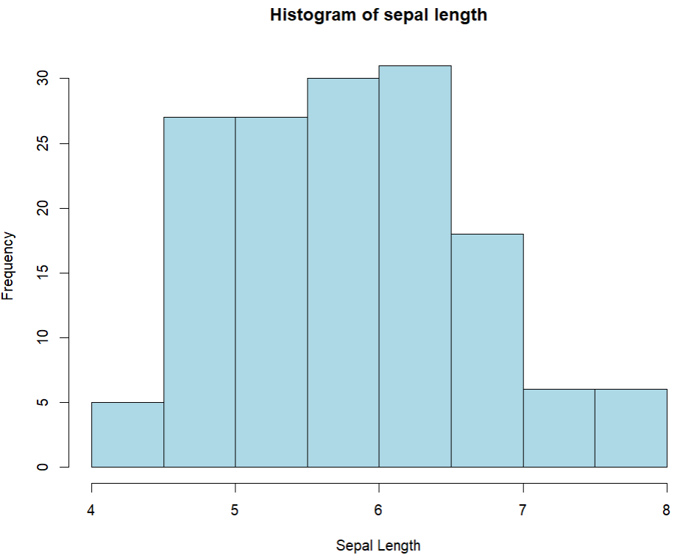
Boxplot of Petal Length
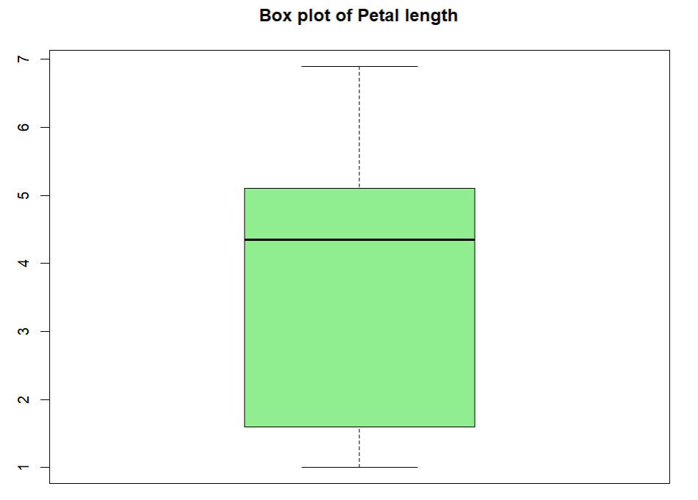
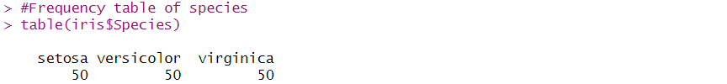
scatter plot Sepal.Length vs Sepal.Length
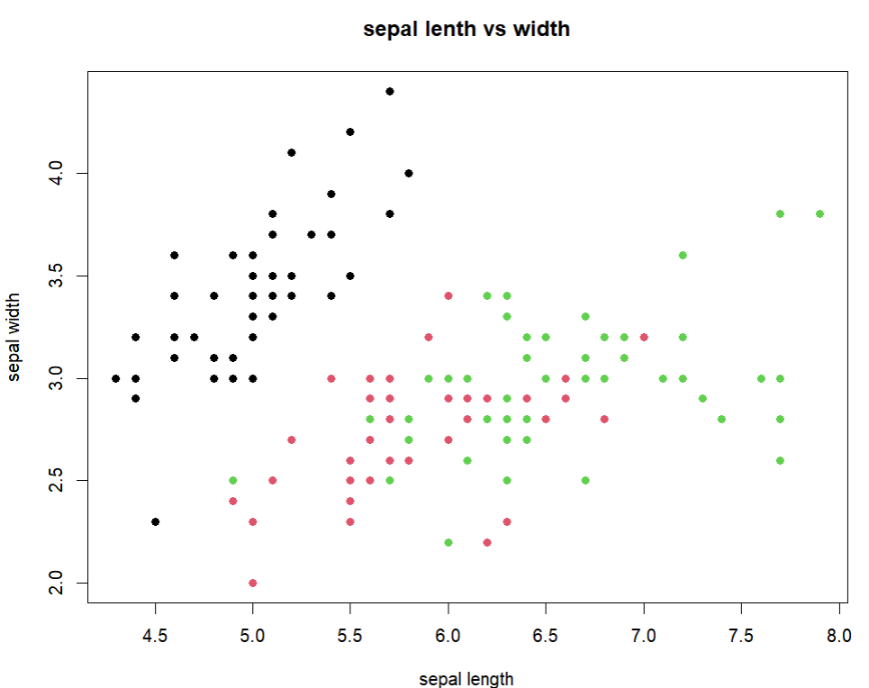
Boxplot of petal.length by species

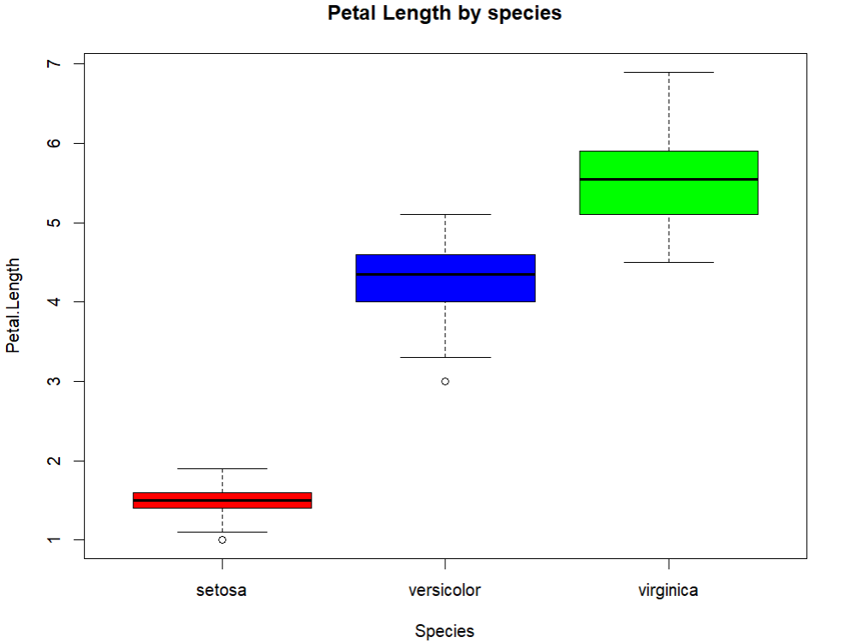
correlation between numeric variables
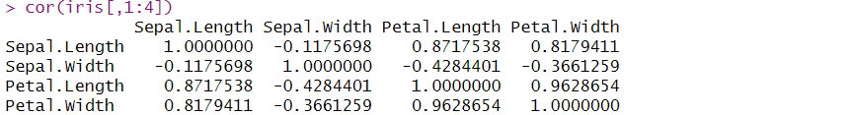
Pairplot (scatter matrix)
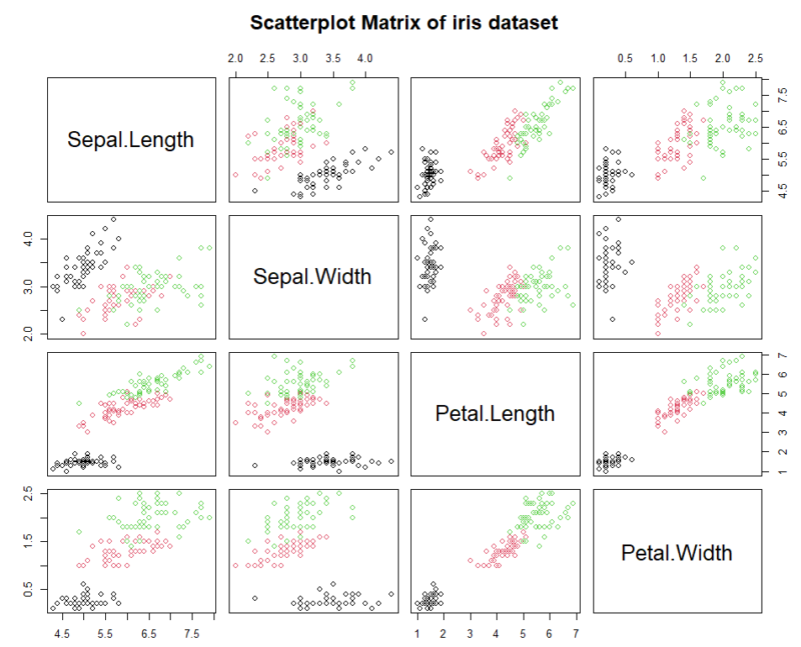
Muti-variate boxplot
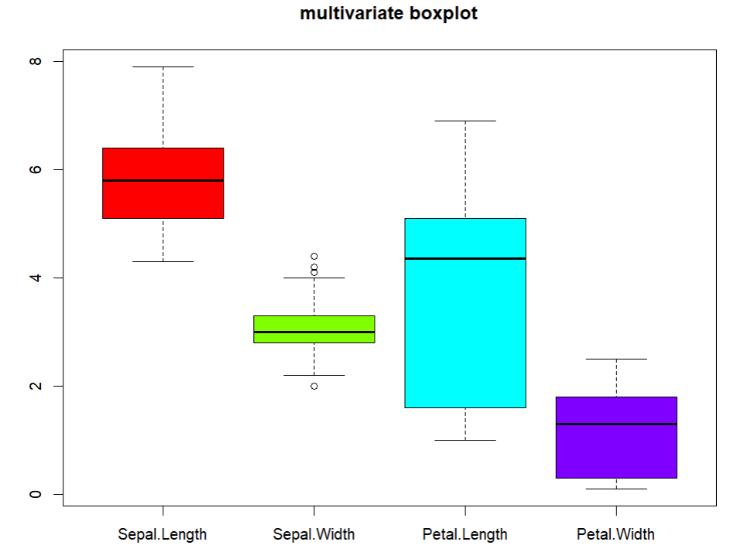
Principal Component Analysis (PCA)
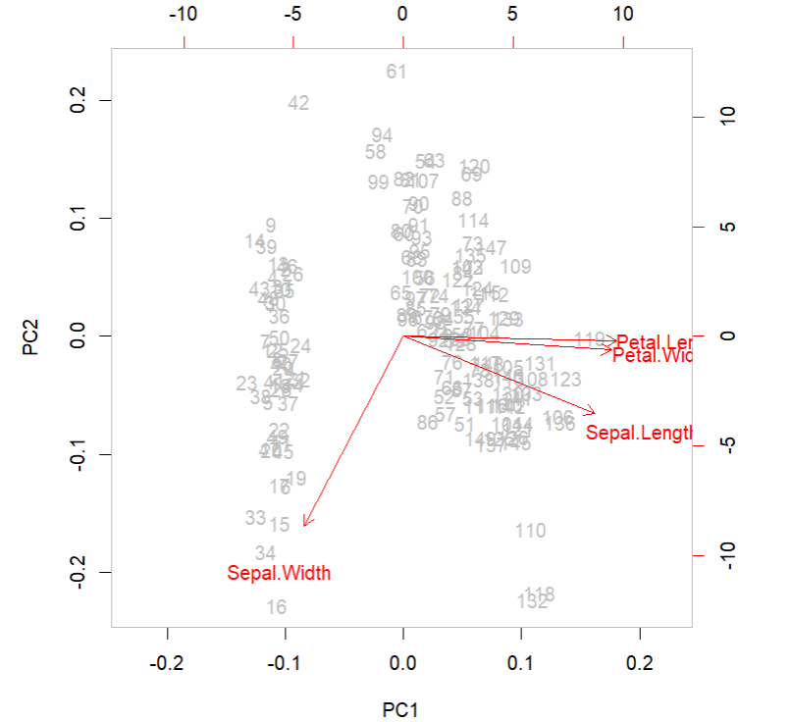
Summary
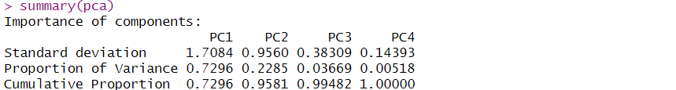

Practical 10
Calculate Summary Statistics in Excel
Descriptive Statistics
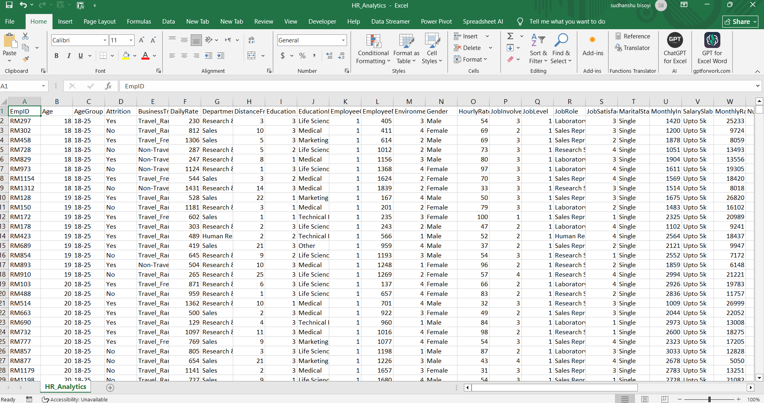
1.Inbuild Function
2. Tool Pak
Click on File which is on top-left corner. then click on Options which is on bottom-left corner.
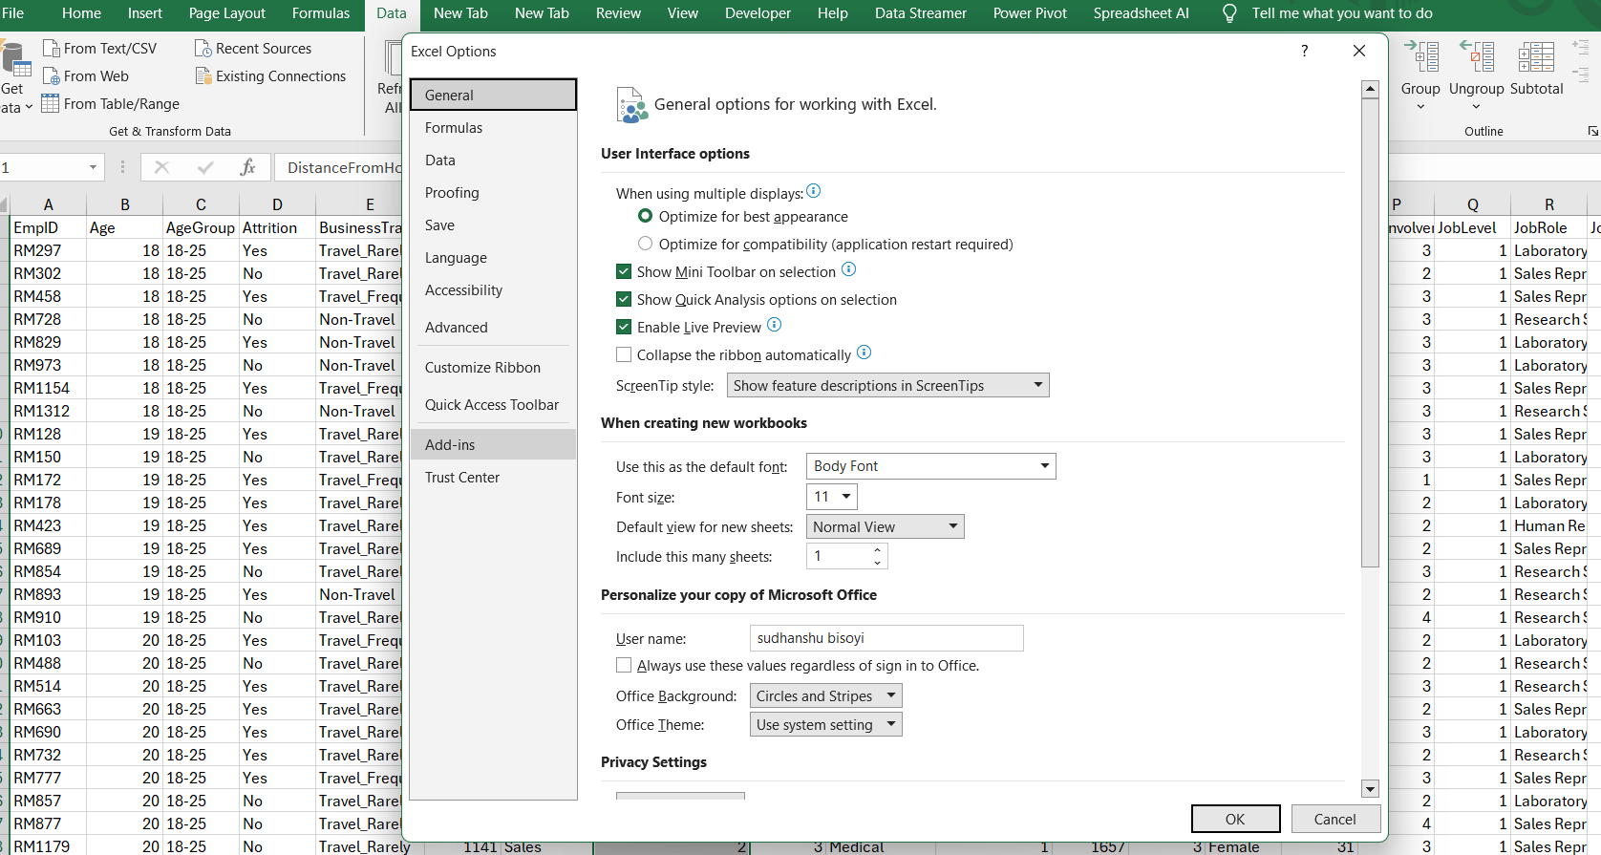

Then click on Add-ins option. Then Click on Go..
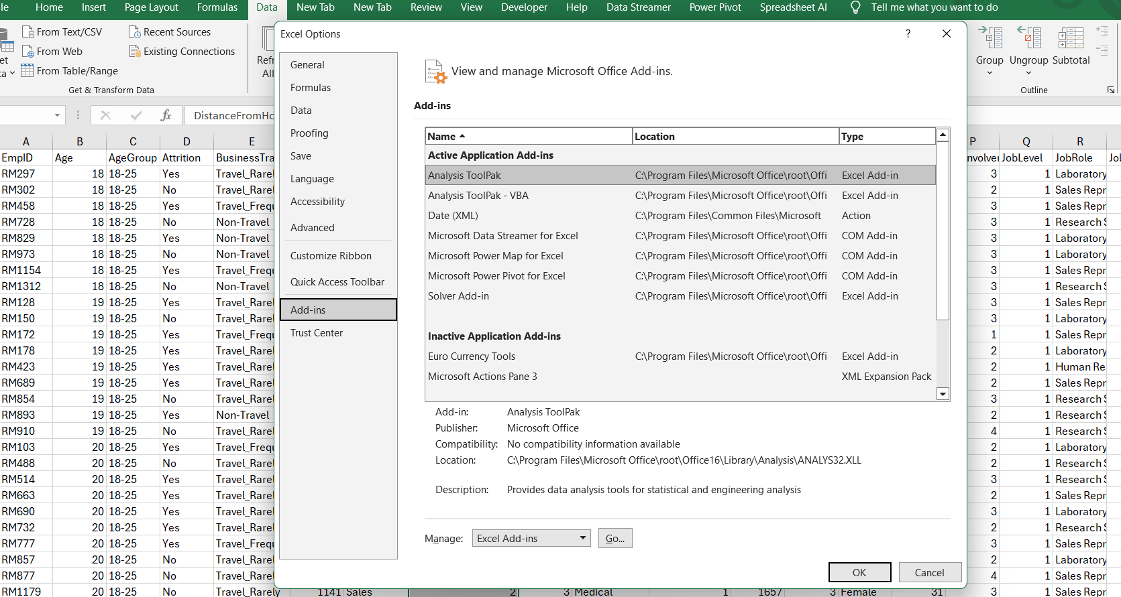
We will see Add-ins options and then check in 3 options and click on OK button.
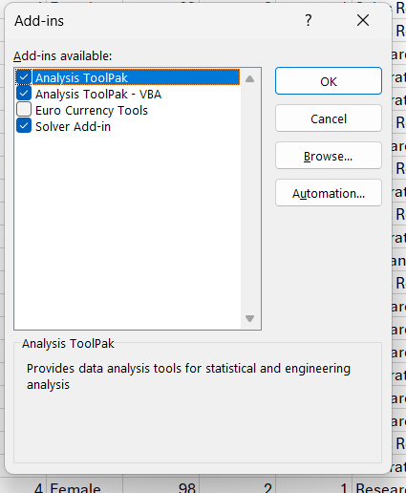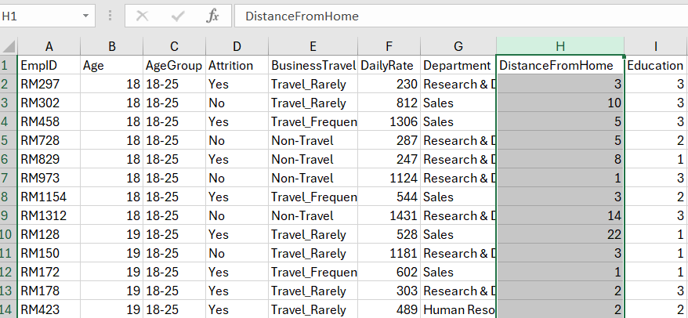
Click on Data which is located in ribbon at the top of the excel window. And then click on Data Analysis which is at the top-right corner.
Select Descriptive Statistics and press OK. Then select the input range from the column which we want to summarize. Check-in options which shown below.
If you want summary in new sheet then check-in new worksheet option or else you want on existing worksheet then check-in Output Range and select the range where you want your summary output.
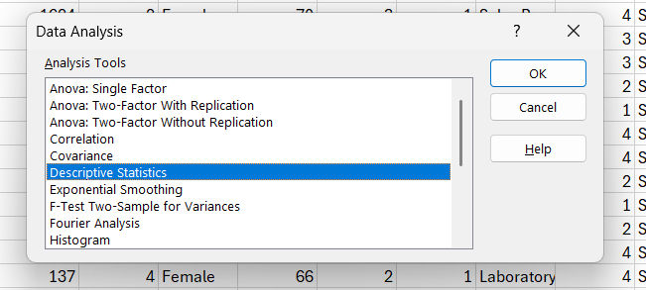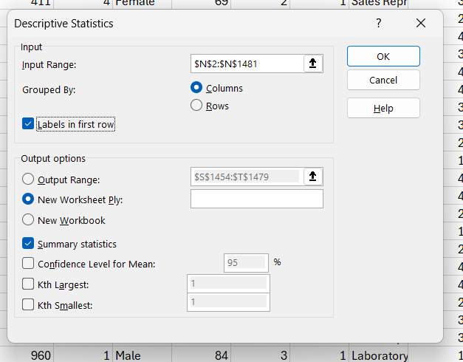

Summary Output:
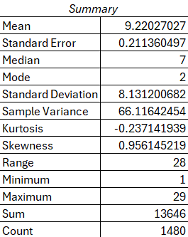
3.Pivot Table
In this case we want to pivot the column named [Distance From Home]. Then clicked on Insert from the ribbon toolbar and click on Pivot Table option then select [From Table/Range].
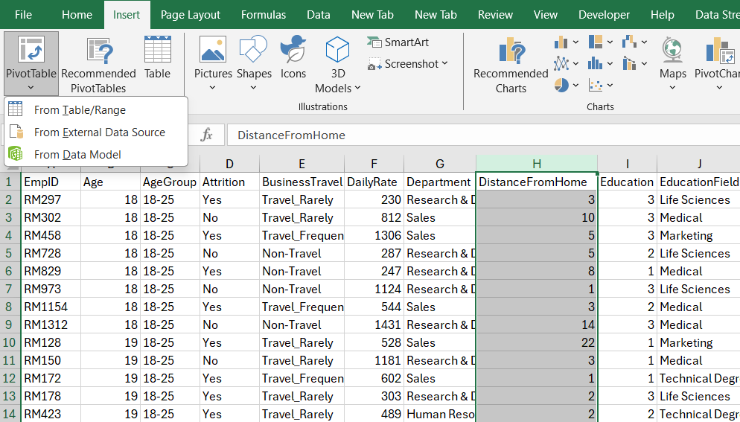
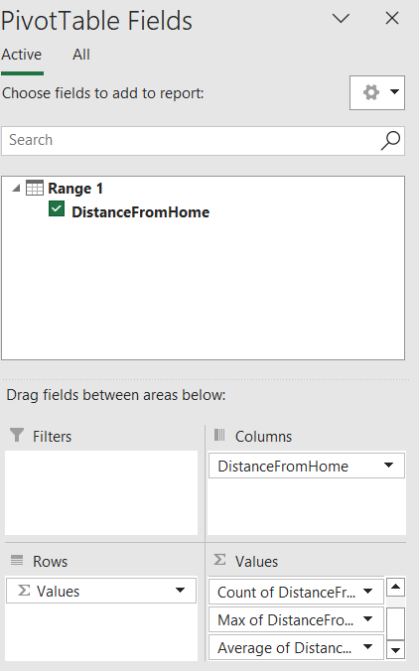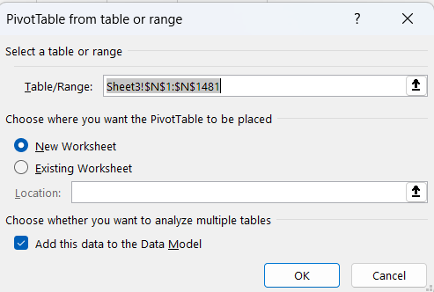
For the row wise pivot table you drag the values to Rows.
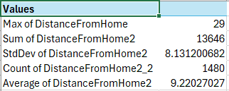
For the column wise pivot table drag the values to Columns.
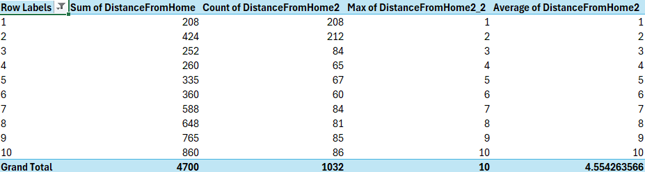

Practical 11
Generate Comparative Statistics in Excel
1.Two Numerical Column
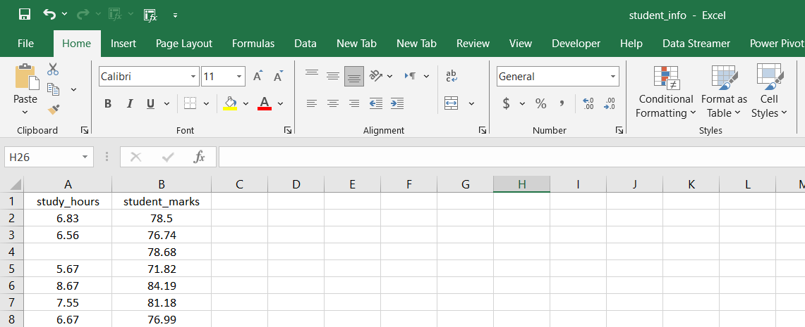
Click on File which is on top-left corner. then click on Options which is on bottom-left corner.
Then click on Add-ins option. Then Click on Go..
We will see Add-ins options and then check in 3 options and click on OK button.
Select Descriptive Statistics and press OK. Then select the input range from the column which we want to summarize. Check-in options which shown below.
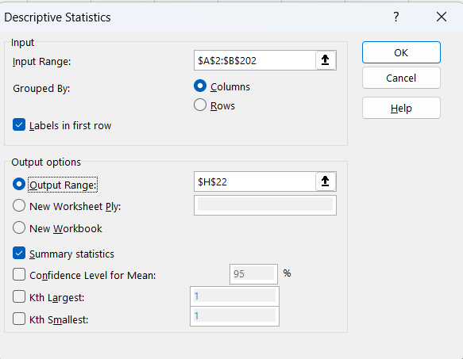
Comparative Statistics:
2.From HR_Analytics dataset we selected the 1 categorical and 1 numerical column
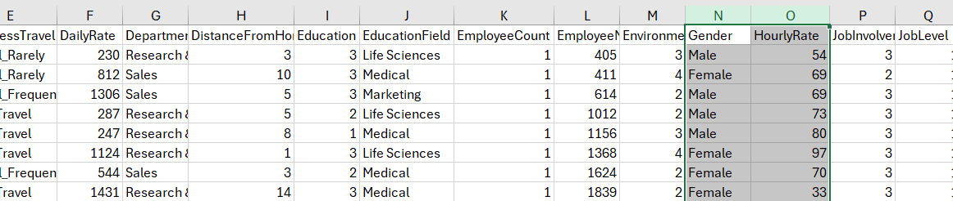
ToolPak
3.Pivot Table
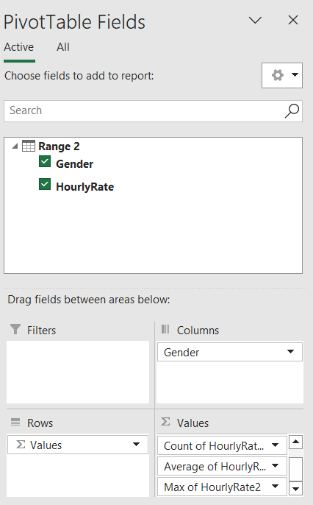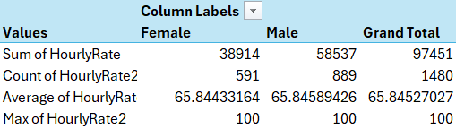
IF In-build
Practical 12
Create Graph in Excel
1. For 1 Numerical Column [Using Student_info dataset]
Box Plot

Histogram

2. For Two Numerical Column [Using Student_info dataset]

3. For 1 Categorical and 1 Numerical [Using HR_Analytics dataset]
Column Chart

Pie Chart

Month-Wise data
Using Sales data
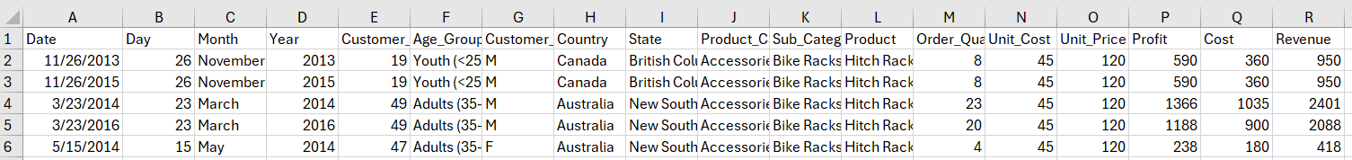
Sorted month-wise
Firstly, select the column you want to sort then click on Data which located in ribbon at the top-window.
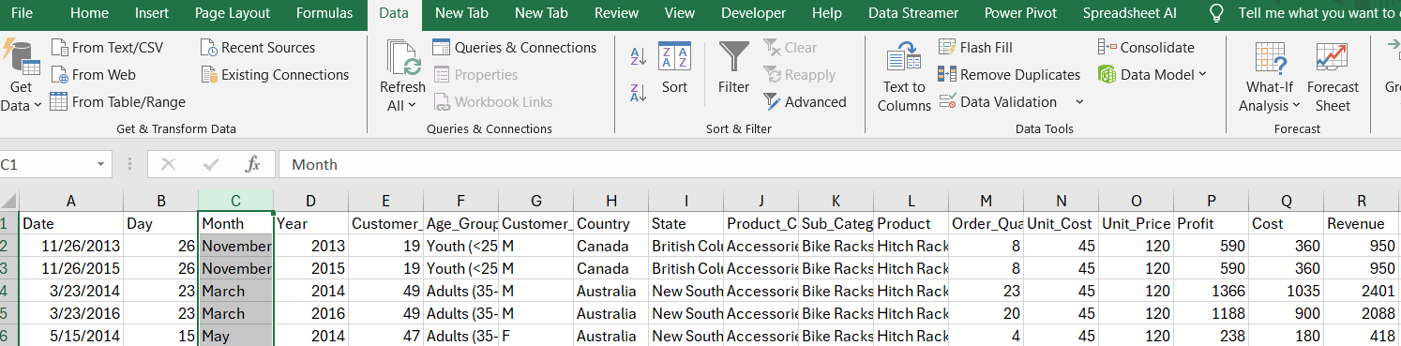
Click on Sort which is at below the view toolbar.
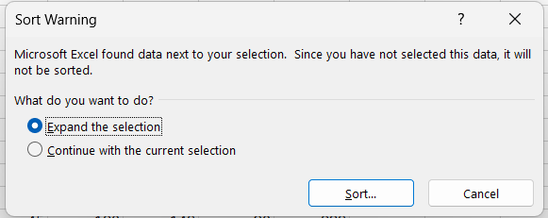
Then choose the option Month in sort by and by choosing custom select the order by month.
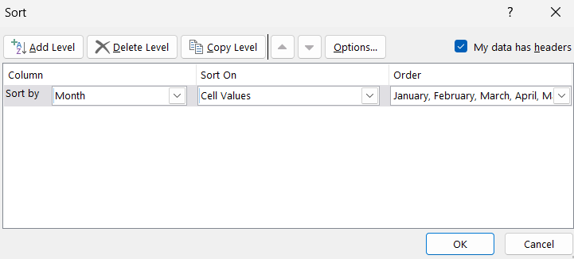
Now, it is sorted by month
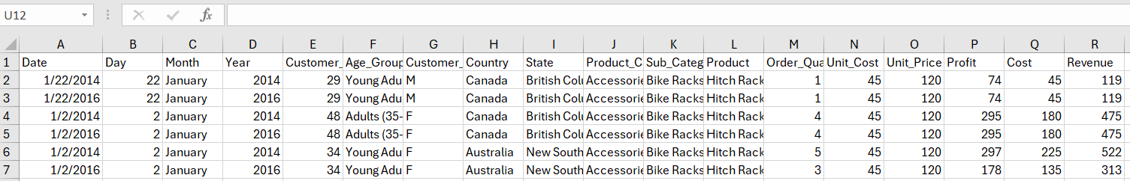
Line Graph With Pivot Table
Select the columns and click on insert and then select line chart on chart section.

Line Graph Without Pivot Table

Practical 13
Advanced Data Analysis using PivotTables and Pivot Charts
Using Sales Data

Column Chart

Line Chart

Practical 14
Tabulation, bar diagram, Multiple Bar diagram, Pie diagram, Measure of central tendency: Mean, median, mode, Measure of dispersion: variance, standard deviation, Coefficient of variation. Correlation, regression lines

For Subject A

For Subject B

Multiple Bar Plot

Scatter Plot

Practical 15
t-test , F-test, ANOVA one way classification, chi square test, independence of attributes
t-test
t-Test: Two-Sample Assuming Unequal Variances
F-test
F-Test Two-Sample for Variances
Conclusion: The calculated value is less than critical value so we accept the Null Hypothesis.
ANOVA one way classification
Anova: Single Factor
Summary
ANOVA
Conclusion – we reject null hypothesis
Chi-Square test
Conclusion – we reject null hypothesis

Practical 16
Time series: forecasting Method of least squares, moving average method. Inference and discussion of results
Using Sales data

Sorted month-wise
Firstly, select the column you want to sort then click on Data which located in ribbon at the top-window.

Click on Sort which is at below the view toolbar.

Then choose the option Month in sort by and by choosing custom select the order by month.

Now, it is sorted by month

Method of Least Squares

Moving Average Method
Ribbon Data Analysis group Data Analysis Moving Average Ok
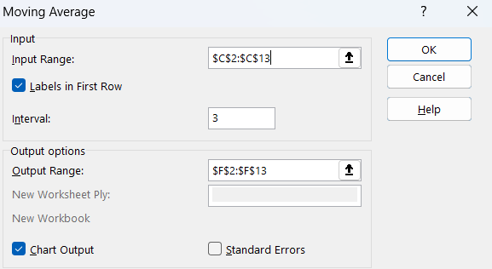
3-Year Moving Average

4-Year Moving Average

5-Year Moving Average

